CS550 Project3

Name: Yin Xue

ONID: 933014789

Email: [xueyi@oregonstate.edu](mailto:xueyi@oregonstate.edu)

Video link: <https://media.oregonstate.edu/media/t/0_fr3b4o5y>

First Texture:

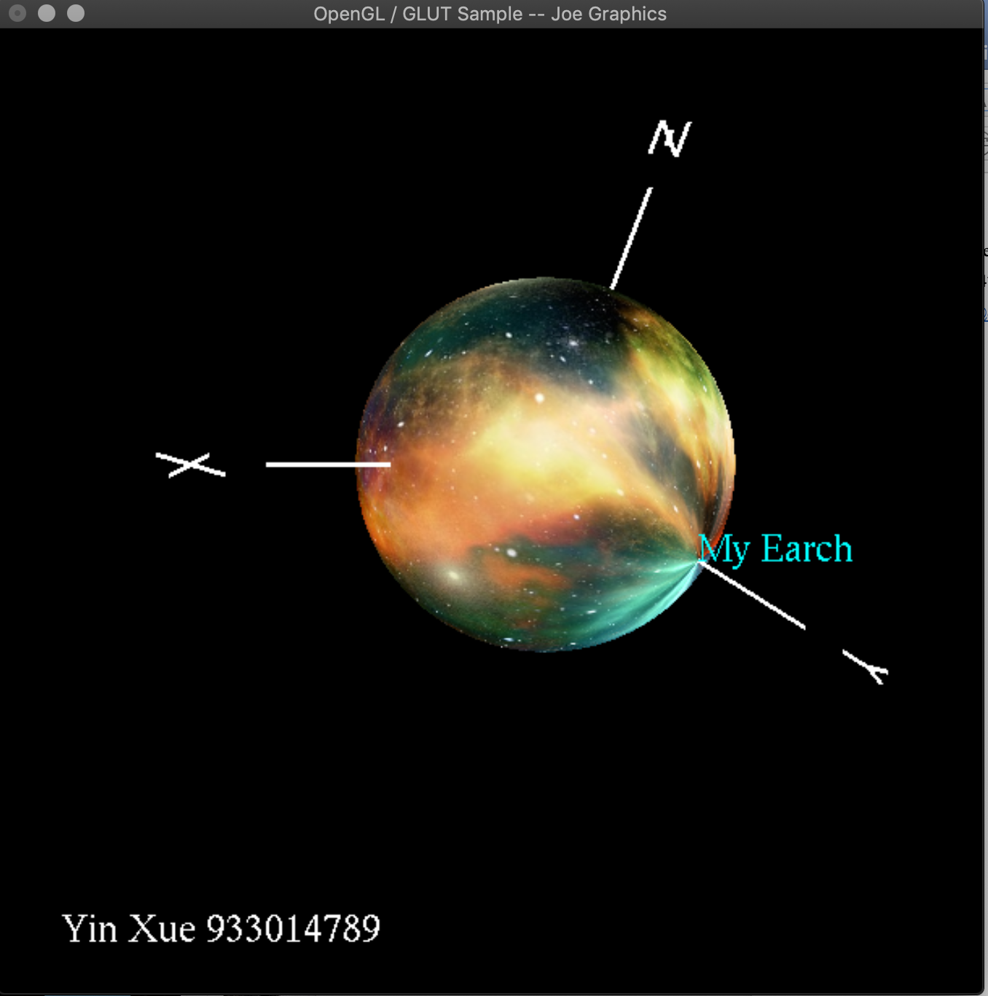

Second Texture:

